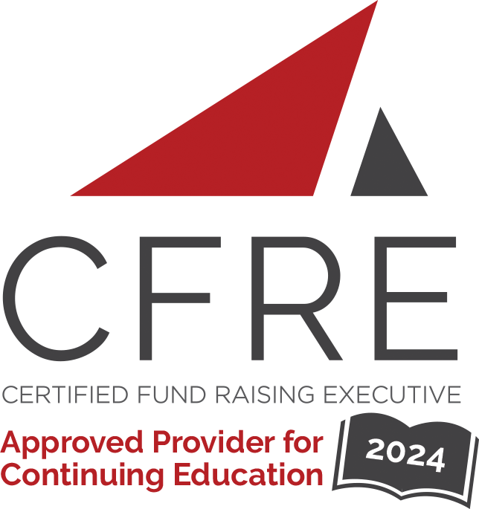  CFRE International has developed this form as a way for you to quickly track (and keep in your files!) the continuing education sessions you have attended. Simply check the boxes next to the sessions you attended. At the end of the conference, add up the total number of hours. Keep this sheet and you will be ready to complete your application form. All of the session slots listed are eligible for continuing education points on your CFRE application for initial certification and/or recertification. Sessions not listed here are not eligible for points. |  | CONTINUING EDUCATION POINTS TRACKER

Activity Organizer: - AFP Québec
Title of Activity: - Webinaires
Names of Presenter(s): - Various
Dates and Location: - 2024

Date: 22 février 2024
Session 1: 12:00 – 13:00 (1.0 pts)
- L’intelligence artificielle en philanthropie: principales utilisations, regard critique et études de cas

Date: 30-31 mai, 2024
Session 1: (16 pts)
- Cours ABC de la collecte de fonds

Date: Day Month, 2024
Session 1: 0:00 [am/pm] – 0:00 [am/pm] (0.0 pts)
- [Session Title]
- [Session Title]
- [Session Title]
- [Session Title]

Date: Day Month, 2024
Session 1: 0:00 [am/pm] – 0:00 [am/pm] (0.0 pts)
- [Session Title]
- [Session Title]
- [Session Title]
- [Session Title]

Date: Day Month, 2024
Session 1: 0:00 [am/pm] – 0:00 [am/pm] (0.0 pts)
- [Session Title]
- [Session Title]
- [Session Title]
- [Session Title]

Date: Day Month, 2024
Session 1: 0:00 [am/pm] – 0:00 [am/pm] (0.0 pts)
- [Session Title]
- [Session Title]
- [Session Title]
- [Session Title]

Date: Day Month, 2024
Session 1: 0:00 [am/pm] – 0:00 [am/pm] (0.0 pts)
- [Session Title]
- [Session Title]
- [Session Title]
- [Session Title]

Total number of points attained: __________

