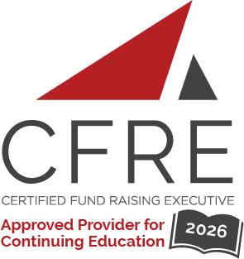  CFRE International has developed this form as a way for you to quickly track (and keep in your files!) the continuing education sessions you have attended. Simply check the boxes next to the sessions you attended. At the end of the conference, add up the total number of hours. Keep this sheet and you will be ready to complete your application form. All of the session slots listed are eligible for continuing education points on your CFRE application for initial certification and/or recertification. Sessions not listed here are not eligible for points. |  | CONTINUING EDUCATION POINTS TRACKER

Activity Organizer: AFP Québec

Date: 27 janvier 2026
12 h à 13 h 15 (1.25 pts)
- [Webinaire sur la gouvernance - Cabinet de campagne : rôle et valeur ajoutée au sein de votre organisation]

Date: 19 février 2026
18 h 30 à 19 h 30 (1.0 pts)
- [Deux causes, une ville : naviguer entre collaboration et compétition en campagnes majeures de financement]

Date: 12 mars 2026
12 h à 13 h 15 (1.25 pts)
- [Leadership au féminin : regards croisés, parcours inspirants et stratégies concrètes]

Date: 23 avril 2026
12 h à 13 h 15 (1.25 pts)
- [Learn from One of Canada’s Most Transformative Campaigns]

Date: 21 mai 2026
12 h à 13 h 15 (1.25 pts)
- [Et si la générosité s’apprenait sur les bancs d’école?]

Date: 28-29 mai ou 11-12 juin, 2026
8 h à 17 h 15 (16.0 pts)
- [Cours ABC de la collecte de fonds]

Date: Day Month, 2026
Session 1: 0:00 [am/pm] – 0:00 [am/pm] (0.0 pts)
- [Session Title]

Date: Day Month, 2026
Session 1: 0:00 [am/pm] – 0:00 [am/pm] (0.0 pts)
- [Session Title]

Date: Day Month, 2026
Session 1: 0:00 [am/pm] – 0:00 [am/pm] (0.0 pts)
- [Session Title]

Date: Day Month, 2026
Session 1: 0:00 [am/pm] – 0:00 [am/pm] (0.0 pts)
- [Session Title]

Date: Day Month, 2026
Session 1: 0:00 [am/pm] – 0:00 [am/pm] (0.0 pts)
- [Session Title]

Total number of points attained: __________

